Project Design Phase
Problem – Solution Fit Template

Date | 02 July 2026
Team ID
Project Name
Maximum Marks | 2 Marks

Problem – Solution Fit Template:
The Problem-Solution Fit simply means that you have found a problem with your customer and that the solution you have realized for it actually solves the customer’s problem. It helps entrepreneurs, marketers and corporate innovators identify behavioral patterns and recognize what would work and why
1. Identified Customer Behavioral Patterns
- The Court Bookers (Students & Teams): They show dynamic, spontaneous scheduling habits. They demand instant mobile-first slot confirmations, prefer clear visibility of court availability, and are highly deterred by slow manual approval processes.
- The Facility Staff (Admins): They rely on reactive management patterns. They spend hours manually reconciling calendar conflicts, tracking down missing sports gear, and dealing with complaints regarding lane-hogging or sudden unnotified cancellations.
2. Recognized Problems with Your Customer
- Scheduling Friction: Users face constant double-bookings and lack a central interface to view open slots across different sport configurations (Badminton, Basketball, Futsal).
- Resource Leaks: High vacancy rates occur during peak hours due to unutilized "ghost reservations" and user "no-shows" that lock up courts from others.
- Asset Disorganization: Handing out and collecting sports equipment rentals is completely untracked, causing inventory loss and asset decay.
3. Why the Realized Solution Works
The realized ServiceNow Service Portal Application achieves perfect fit because it aligns automated platform logic with these established user behaviors:
- Frictionless Interface: The AngularJS portal widget provides an instant, interactive visual calendar. Users can secure a court and choose add-on gear in under three clicks.
- Automated Fairness Rules: Backend business logic restricts maximum booking caps per account. This stops court-hogging automatically, removing manual oversight tasks from the administrator.
- Auto-Release Automation: An integrated Flow Designer workflow monitors slot check-ins. If a user is a "no-show" for 15 minutes, the engine cancels the record, releases the slot back to the public ledger, and alerts waitlisted users via Twilio SMS.
- Unified Cloud Ledger: Consolidating court availability and gear tracking into custom relational tables removes human error, ensuring the facility runs at maximum utilization.

Template:
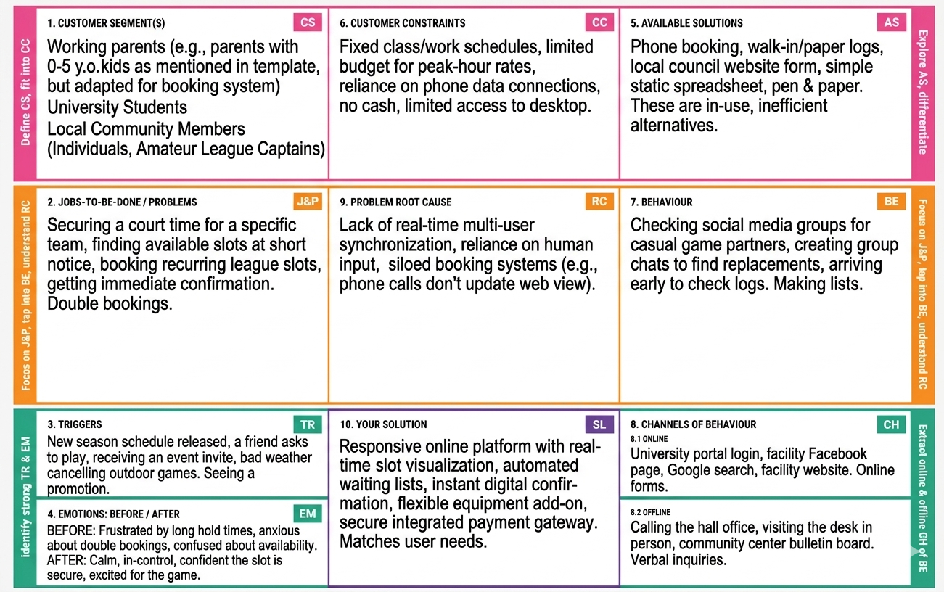
References:
- Idea Hackers Network
- Medium Problem-Solution Fit Canvas Guide.

